**Insertion Sort**

Sorting is the process of arranging a list of elements in a particular order (Ascending or Descending).Insertion sort algorithm arranges a list of elements in a particular order. In insertion sort algorithm, every iteration moves an element from unsorted portion to sorted portion until all the elements are sorted in the list.

**Step by Step Process**

The insertion sort algorithm is performed using following steps...

**Step 1:** Assume that first element in the list is in sorted portion of the list and remaining all elements are in unsorted portion.

**Step 2:** Consider first element from the unsorted list and insert that element into the sorted list in order specified.

**Step 3:** Repeat the above process until all the elements from the unsorted list are moved into the sorted list.

**Sorting Logic**

Following is the sample code for insrtion sort...

**//Insertion sort logic**

for i = 1 to size-1

{

temp = list[i];

j = i;

while ((temp < list[j]) && (j > 0))

{

list[j] = list[j-1];

j = j - 1;

}

list[j] = temp;

}

Example

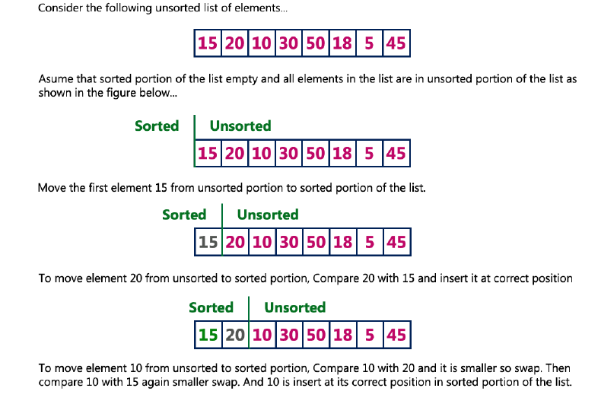

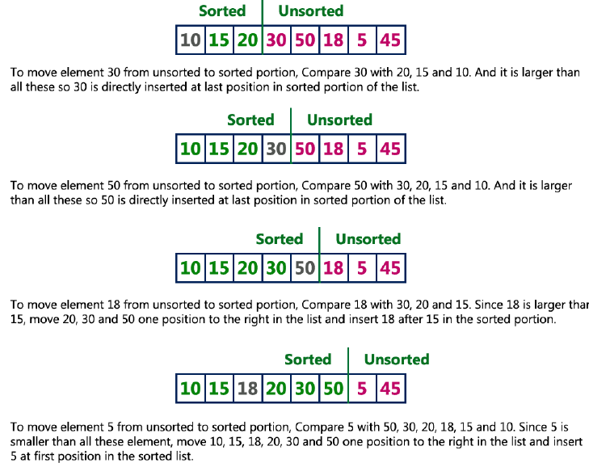

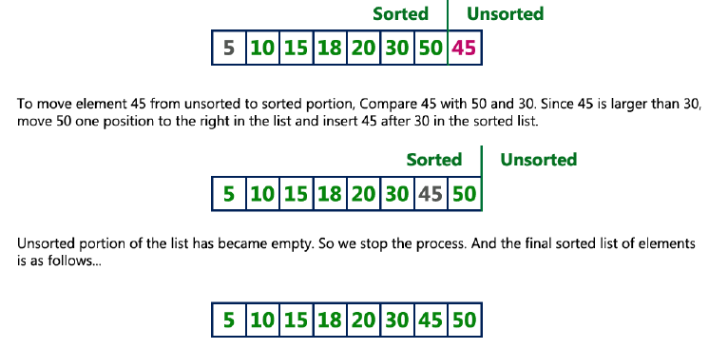

**Complexity of the Insertion Sort Algorithm**

To sort a unsorted list with **'n'** number of elements we need to make **(1+2+3+......+n-1) = (n (n-**

**1))/2** number of comparisons in the worst case. If the list already sorted, then it requires **'n'** number of comparisons.

**Worst Case : O(n2)**

**Best Case : Ω(n)**

**Average Case : Θ (n2)**

**Insertion Sort Program in C Programming Language**

#include<stdio.h>

#include<conio.h>

void main(){

int size, i, j, temp, list[100];

printf("Enter the size of the list: ");

scanf("%d", &size);

printf("Enter %d integer values: ", size);

for (i = 0; i < size; i++)

scanf("%d", &list[i]);

//Insertion sort logic

for (i = 1; i < size; i++) {

temp = list[i];

j = i - 1;

while ((temp < list[j]) && (j >= 0)) {

list[j + 1] = list[j];

j = j - 1;

}

list[j + 1] = temp;

}

printf("List after Sorting is: ");

for (i = 0; i < size; i++)

printf(" %d", list[i]);

getch();

}